ECA3101-NANO ELECTRONICS
Exp. 1. Simulation of Energy States of Quantum Dot using NanoHub
TEST CASE-1:Pyramid Structure
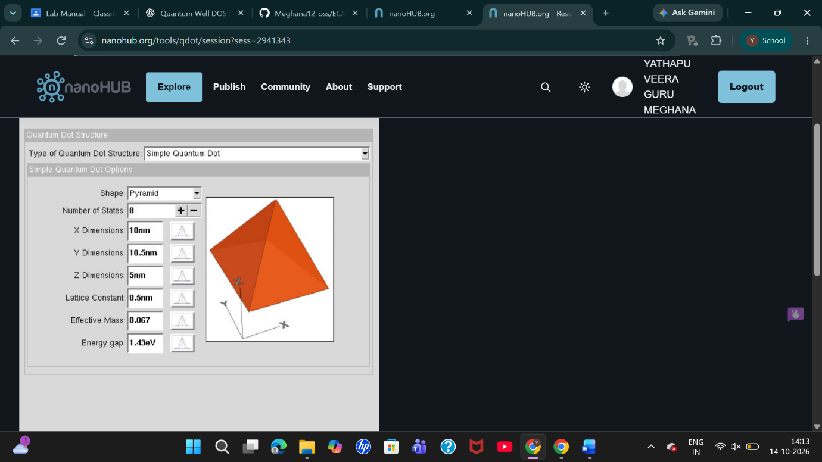
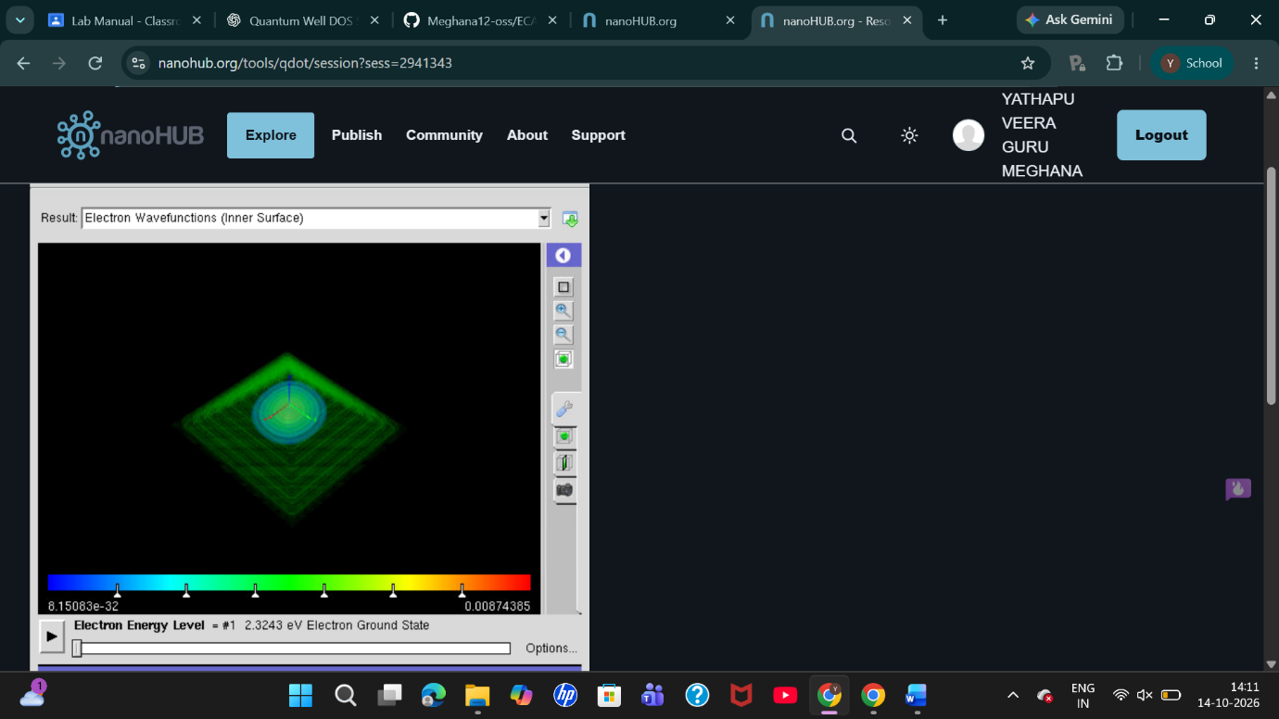
TEST CASE-2: Cylinder Structure
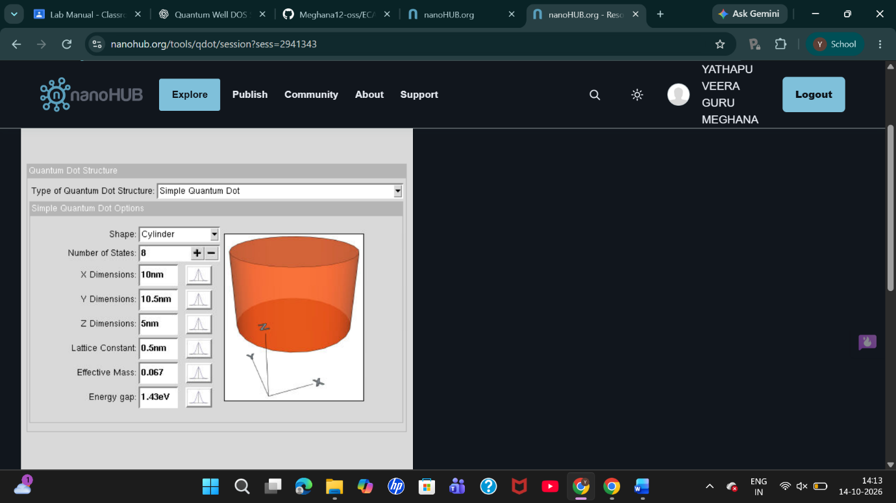
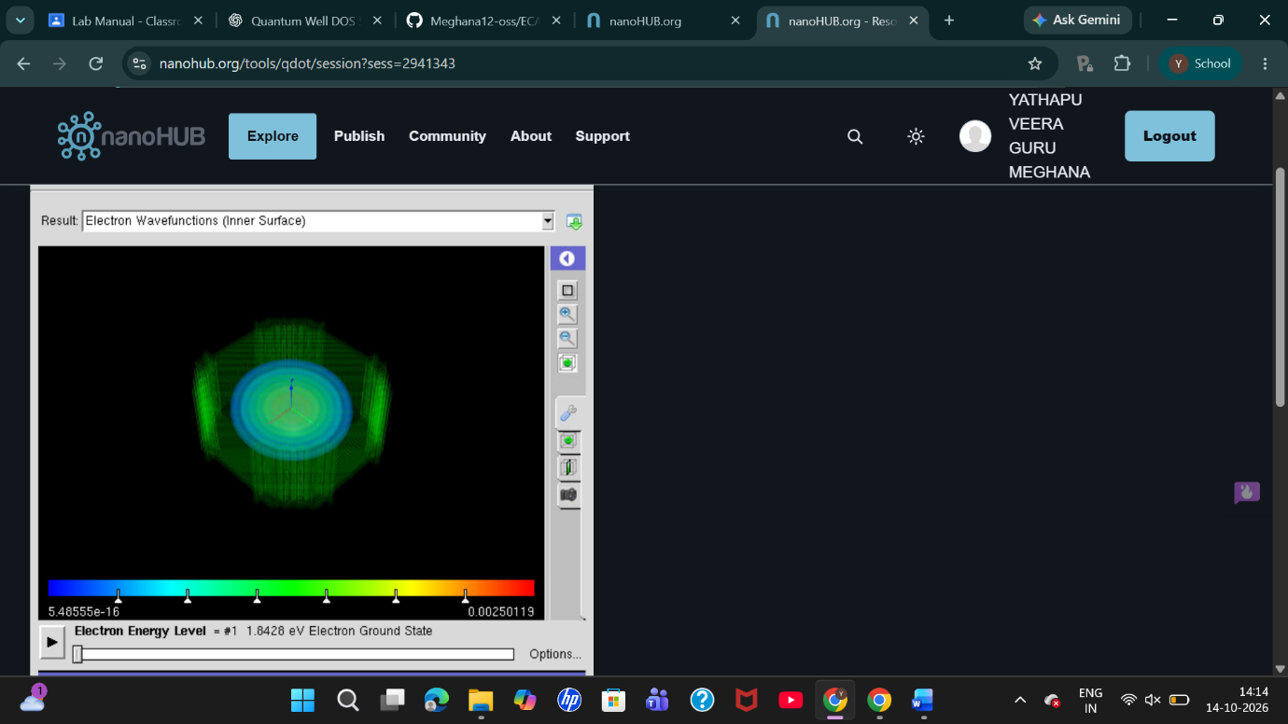
TEST CASE-3: Cuboid Structure
